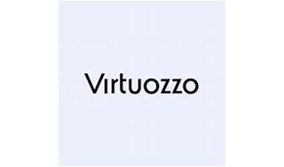



Explore

**Virtuozzo** is a **cloud platform** designed for **service providers**, **MSPs**, and **hosts**. It offers a **production-ready OpenStack cloud**, **Kubernetes as a Service**, **Database as a Service**, and more. [With Virtuozzo, you can provide an alternative to hyperscale cloud solutions](https://www.virtuozzo.com/) [1](https://www.virtuozzo.com/).

Here are **five reference links** where you can learn more about Virtuozzo:

1. [**Virtuozzo Official Website**](https://www.virtuozzo.com/): Explore their cloud platform, services, and solutions.
2. [**About Virtuozzo**](https://www.virtuozzo.com/company/about/): Learn about their history as industry pioneers in container technology.
3. [**Wikipedia - Virtuozzo (company)**](https://en.wikipedia.org/wiki/Virtuozzo_%28company%29): Discover details about their virtualization and cloud management software.
4. [**Webinar: OpenStack VMware Alternative**](https://www.virtuozzo.com/): Attend a live demo to understand how Virtuozzo compares to VMware.
5. [**Virtuozzo Announces Free Migration Program**: Read about their free migration program for VMware Cloud Providers](https://www.virtuozzo.com/) [1](https://www.virtuozzo.com/)[2](https://www.virtuozzo.com/company/about/)[3](https://en.wikipedia.org/wiki/Virtuozzo_%28company%29).